SUMMONS TO THE PARISH COUNCIL MEETING

AT THE NEW VICTORY HALL

**Thursday 20th July 2023 at 7.30pm**

For the purpose of transacting the following business

Press and public are welcome to attend. At item 4 the public will be invited to give their views/questions to the Parish Council on issues on the agenda or raise issues for consideration of inclusion at a future meeting. This item is limited to 15 minutes.

# Apologies

To consider apologies for absence

# Declarations of Interest and Applications for Dispensation

Members are invited to declare a previously undisclosed interest relating to items on the agenda and to receive any applications for dispensations.

# minutes of the previous meeting

To confirm and agree the minutes of the Parish Council meeting held on 15th June 2023

# Public SPEAKING

The meeting will be adjourned for up to 15 minutes:

To receive reports from County and District Councillor & Cluster 12 Police Magazine update

To receive questions from members of the public relating to items on the agenda. Each speaker is allowed a maximum of 5 minutes.

# Matters Arising – TO RECEIVE UPDATES

1. Financial Regulations Policy review
2. Risk Assessments
3. Consider £250 grant to St Peters Church
4. SAM2 data analysis
5. Gift shop request to advertise at the staithe

# Maintenance

|  |  |  |
| --- | --- | --- |
| LOCATION | ISSUE | PROGRESS |
| staithe | holes in ground causing trip hazard, TREE and rotting wood hazard | review at next risk assessment |
| Staithe | Gap between residents’ fence and end of path, wooden capping needs replacing | EML sent to BA to replace missing capping on mooring side. Meeting with residents required to discuss fencing side |
| Staithe | TAP IMPROVEMENT | COMPLETED |
| Allotment | Football games are damaging plot | consider quote for fencing from abc landscaping |
| Playing field | some netting on one goal post could benefit from being fixed |  |

# Planning

1. New Applications (North Norfolk District Council)

i. PF/23/1384 Street Hill Farm The Street Neatishead Norwich Norfolk NR12 8XG Erection of two-storey rear and side extension, front porch, addition of dormer window to side elevation and enlargement of first floor window on front elevation

ii. PF/23/1306 Caldarvan Common Road Threehammer Common Neatishead Norwich Norfolk NR12 8BP Two storey extension with first floor balcony; porch extension; additional ground and first floor window openings in north elevation; detached building with garaging and home office/studio following removal of dilapidated garage and outbuildings; alterations to access (revisions to previously approved application PF/21/3300)

iii. PF/23/1340 Meadow Way, Common Road, Threehammer Common, Neatishead, Norwich, Norfolk, NR12 8BPErection of cart lodge to front of property

1. New Applications (Broads Authority)

None

1. Decisions and Appeals (North Norfolk District Council)

i. PF/23/0915 Meadowrise Sow's Loke Neatishead Norwich Norfolk NR12 8BS Single storey extension and alterations to dwelling APPROVED

1. Decisions and Appeals (Broads Authority)

None

# Correspondence and Consultations

Letter received from school children enquiring what the parish council are doing to discourage the use of plastic within the village. Consider letter of response.

# Financial matters

1. Financial Update

**Main Account – Balance as at 13th July 2023 £3,263.22**

**Income**

04/07/2023 HMRC VTR £294.18

**Payments**

12/06/2023 Country Style Recycling £30.00

19/06/2023 Laura Bateman salary £347.52

19/06/2023 Laura Bateman expenses £13.95

20/06/2023 Internal auditor £65.00

21/06/2023 New Victory Hall £19.00

21/06/2023 New Victory Hall £19.00

23/06/2023 Zurich Insurance £476.88

27/06/2023 Anglian Water £38.00

**Saving Account – Balance as at 13th July 2023 £2,960.87**

**Income**

10/07/2023 Interest £2.01

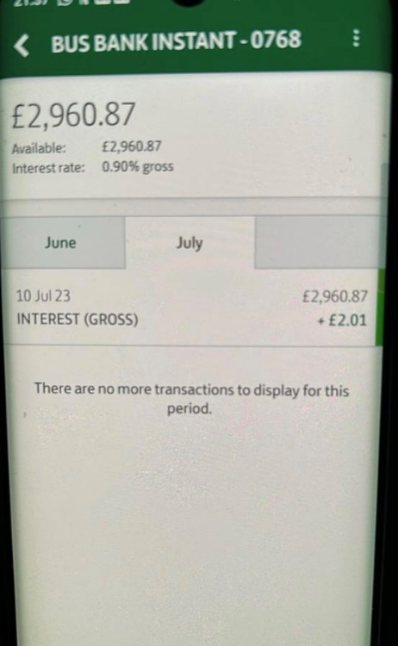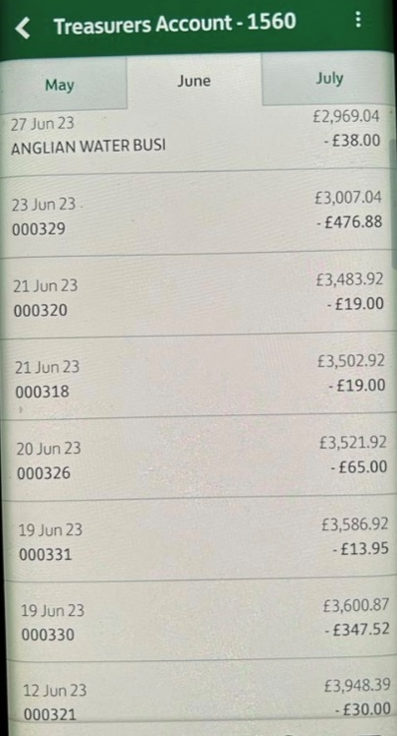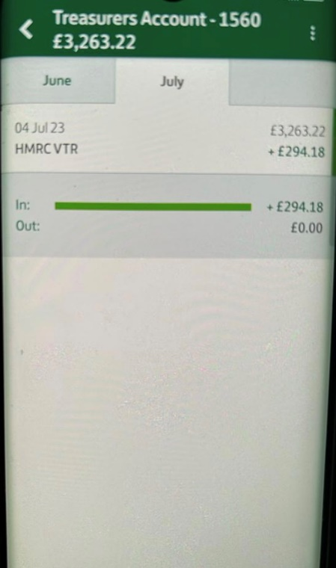

1. To consider payment of the following:

L Bateman Salary June – July 2023 30 hours @ £14.48 £434.40

L Bateman Expenses (phone/allowance) £13.95

New Victory Hall Room Hire £19.00

Countrystyle Recycling LTD Mixed glass recycling £21.00

Countrystyle Recycling LTD Mixed glass recycling £12.00

J Groarke Oil Boilers Fix tap at staithe £45.00

ABC Landscaping Replacement posts at car park £170.00

1. Quarterly financial update



# STAITHE

1. Discuss the issue of the unauthorised trader selling food from a vehicle
2. Update on having a QR code for water donations instead of a cashbox.

# OTHER matters

None

# NEXT MEETING OF THE PARISH COUNCIL

Thursday 17th August 2023 at 7.30pm at New Victory Hall, Neatishead

*Laura Bateman*

*Clerk to the Parish Council*

*16th July 2023*