Minutes of the Parish Council Meeting of Neatishead Parish Council held on Thursday 21st September 2023 at 7.30pm at New Victory Hall, Neatishead

Present: Cllr Michael Godfrey (Chairman)
Cllr Robert Hanger (Vice-Chairman)
Cllr Alex Craker
Cllr Jane Rutter
Parish Clerk Laura Bateman

Also present: 11 members of the public were also present

Apologies
Cllr Ben Mullard - Neatishead Parish Council
Cllr Gerard Mancini-Boyle - Hoveton & Tunstead Ward, North Norfolk District Councillor
Cllr Richard Price – South Smallburgh Division, Norfolk County Council
PC Matt Pritty – Norfolk Constabulary

Declaration of Interest and applications for dispensations
Cllr Hanger declared an interest in the Poor’s Trust

Minutes of the previous meeting
Cllr Craker requested an amendment to the minutes as the window mentioned at 4.d paragraph 3 and 4, 7.a.ii paragraph 3 was not an additional window but the use of an existing window that was the concern.

Minutes amended and AGREED

Proposed Cllr Godfrey, seconded Cllr Rutter, all in favour

Public Speaking

- County Councillor
The clerk read a report submitted by Cllr Price that the four new 30mph speed roundels for the village will be applied soon. In total 29 new speed roundels will appear in the villages within his division.

- District Councillors
The clerk read a report submitted by Cllr Mancini-Boyle that a new head of planning is to be appointed. Cromer and Mundesley sea defence budget has risen by £10.1M so North Norfolk District Council are applying for additional funding from the government.

- Police
The clerk read a report submitted by PC Pritty. There had been nine calls from the village to the police since 1st August 2023 and he had visited the school several times to speak to drivers regarding their speed. There had been some criminal activity at the caravan site and he asked if anyone had seen any disturbances there to contact him.

d. Public
A member of the public highlighted that some footpaths were not in an adequate condition. They had reported one to the parish council who directed them to the county council highways team. A request for these contact details to be published on the parish council’s website was AGREED and the clerk would find out the progress of the council’s responsibility poster that had been ordered.
ACTION PARISH CLERK

A member of the public expressed concerns regarding speeding vehicles, in particular on Cangate Road by delivery drivers. Pets had been hit, cyclist use this route frequently and electric cars were a concern as they cannot easily be heard. Councillors expressed their support with these concerns. New signs were mentioned and the clerk will enquire to the progress around the application for a 20mph zone although this particular area fell outside this area. The clerk will enquire into the SAM2 camera being located in a different place.
ACTION PARISH CLERK

Matters Arising – TO RECEIVE UPDATES

- Funding for climbing wall including installation date, opening, plaque and NIB article.

Cllr Godfrey announced the Lottery Community Fund application had been granted for funding of a 10m climbing wall at the staithe. The installation date was booked for 27th September 2023. It was AGREED that the wall should be 8m and the rest of the wood to be kept by the council for future use of a bench or table.

It was AGREED that one plaque introducing the wall and detailing safety precautions would be purchased.

Councillors discussed an official opening and Cllr Hanger would make some initial discussions with the school to see if they would like to be involved. The wall could then be officially announced on social media, noticeboards and the website.
ACTION PARISH CLERK

- Financial Regulations Policy Review

Amendments to the policy had been disseminated to the councillors by the clerk. Cllr Craker requested it was noted that the clerks annual review must be completed and a process was needed to implement this. It was highlighted that the manual counting of the staithe water money that was completed by Cllr Craker was a temporary measure until a more robust system is implemented next year. It was AGREED that the policy review was satisfactorily complete.

Proposed Cllr Craker, seconded Cllr Rutter, all in favour

- NPTS Seminar
The clerk requested to attend the Norfolk Parish Training and Support conference on 16th October 2023 at the cost of £54. It covered subjects including planning, social media, defibrillators and risk assessments. It was AGREED the clerk could attend.

Proposed Cllr Craker, seconded Cllr Rutter, all in favour

- Funding for defibrillators

The clerk informed the council some government funding had become available for defibrillators. It was AGREED that the clerk would submit an application.
ACTION PARISH CLERK

- Pie seller update

The clerk reported that following research into the parish councils’ power to stop the pie seller from selling goods at the staithe, legal assistance would be needed for issuing Fixed Penalty Notices and court action if the penalty was not paid. The cost of this could be considerable. It was AGREED to consider this matter next year should the seller return.

- SAM2 update/data analysis

Cllr Rutter summarised the data from the SAM2 camera particularly between 8am until 10am and 2pm until 4pm. The average speed recorded was 32.5mph and all recordings were in excess of 20mph. The clerk is to make enquiries about having the camera installed at a different location than the three it is currently located at.
ACTION PARISH CLERK

Maintenance
LOCATION | ISSUE | PROGRESS
Staithe | Grass regrowth and temporary path cover | The grass is growing well. BA have confirmed they would replace the path in November.
Staithe | Gap between residents’ fence and end of path, wooden capping needs replacing | BA have confirmed the capping would be replaced in November along with the installation of two fence posts for parish council’s boundary fence to be fitted. Clerk to contact residents requesting the old fence is moved before this date so the BA can complete their work and then a new fence can be fitted by the residents.
Allotment | Football games are damaging plot | Repair to existing fence would be more affordable and a visit will be made to see if goal posts can be moved in the other direction. Cllr Hanger to investigate
Playing field | Some netting on one goal post could benefit from being fixed | Cllr Rutter completed repair with some cord

Planning

- New Applications (Norfolk District Council)

i. PF/23/1803 Street Hill Farm The Street Neatishead Norwich Norfolk NR12 8XG, Erection of detached cart lodge with studio above
It was AGREED the council had no comments or objections.
Proposed Cllr Godfrey, seconded Cllr Rutter, all in favour
- New Applications (Broads Authority)
None
- Decisions and Appeals (North Norfolk District Council)

- PF/23/1384 Street Hill Farm The Street Neatishead Norwich Norfolk NR12 8XG Erection of two-storey rear and side extension, front porch, addition of dormer window to side elevation and enlargement of first floor window on front elevation APPROVED

- PF/23/1340 Meadow Way, Common Road, Threehammer Common, Neatishead, Norwich, Norfolk, NR12 8BPErection of cart lodge to front of property APPROVED

- PF/23/0209 Caravan Site Street Hill Farm The Street Neatishead NR12 8XG, Erection of amenity and facilities building for use in association with touring caravan site REFUSED

- PF/23/0536 Swift Cottage Water Lane Neatishead NR12 8BL, Extensions and external alterations to dwelling and garage; construction of detached double garage and store APPROVED

- Decisions and Appeals (Broads Authority)
None

Correspondence and consultations

- EMAIL received from Roger Lamb regarding his permissive footpath. Mr Lamb will do what he can to maintain the path but if this becomes unmanageable, he will need the council’s assistance. Cllr Hanger noted having the use of the path was a considerable asset and thanked Mr Lamb for this. After some discussion it was AGREED for a quote for clearing the path to be obtained so there was a better understanding of the cost involved. This would assist with any decision making going forward.
ACTION PARISH CLERK

- EMAIL received from a member of the public regarding mis-use of the paper recycling bin in the car park. A laminated sign reminding the public of what can go in has been requested. It was AGREED for a laminated sign to be displayed and to include a reminder in the next edition of NIB. Clerk to investigate cost of a general waste bin.
ACTION PARISH CLERK

- EMAIL received regarding an injury to a young boy who fell from the monkey bar at the playground and broke his arm. Request from the parent to have an extra safety sign and improved flooring fitted. It was noted that the flooring met safety standards but it was AGREED to relocate the safety sign from the carpark closer to the play equipment

- LETTER received from Duncan Baker MP inviting a representative of the parish council to attend a public meeting on 27th September 2023 about speeding on rural roads in Norfolk. Cllr Rutter offered to attend.

Financial matters

- Financial Update
Main Account – Balance as at 14th September 2023 £8,930.87

Income
08/09/2023 Community Fund - Grant £6175.00
25/07/2023 Staithe Water £270.00

Payments
25/07/2023 Anglian Water £38.00
26/07/2023 New Victory Hall £19.00
17/08/2023 Laura Bateman salary £434.40
17/08/2023 Laura Bateman expenses £13.95
18/08/2023 J Groarke Boilers £45.00
25/08/2023 Anglian Water £38.00
30/08/2023 New Victory Hall £19.00
08/09/2023 ABC Landscaping £170.00

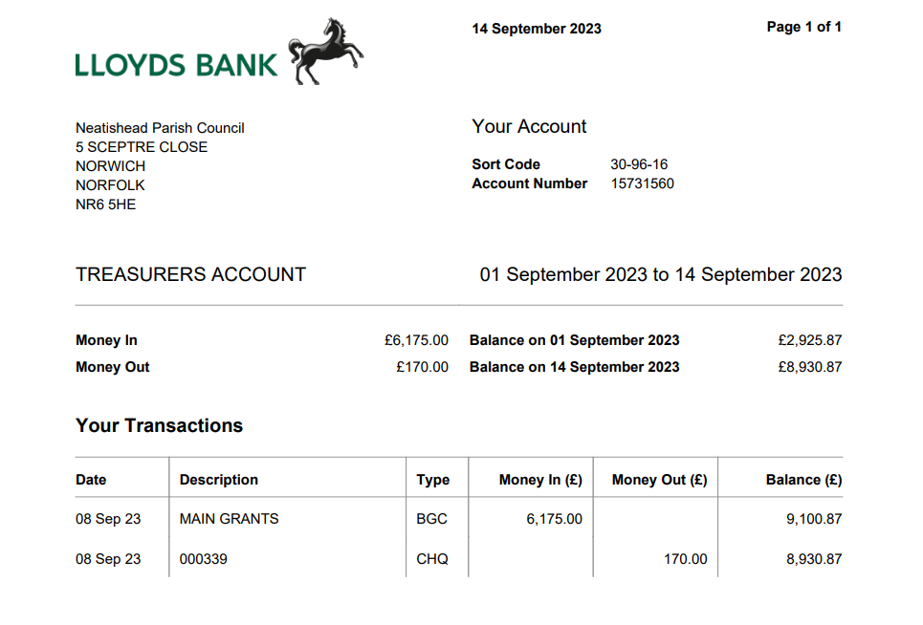
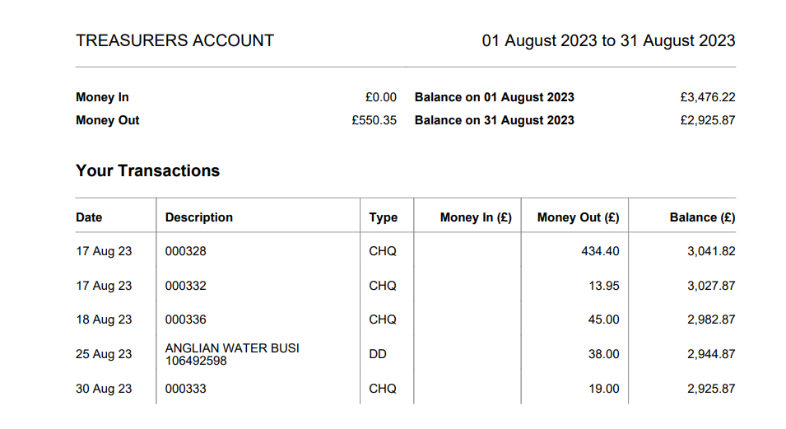
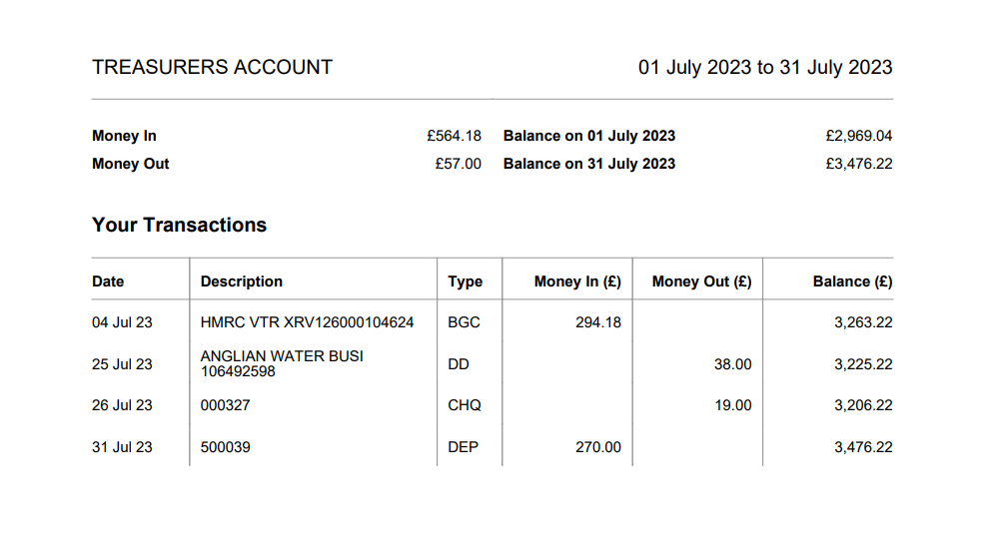

Saving Account – Balance as at 14th September 2023 £2,965.83

Income
09/08/2023 Interest £2.19 11/09/2023 Interest £2.77

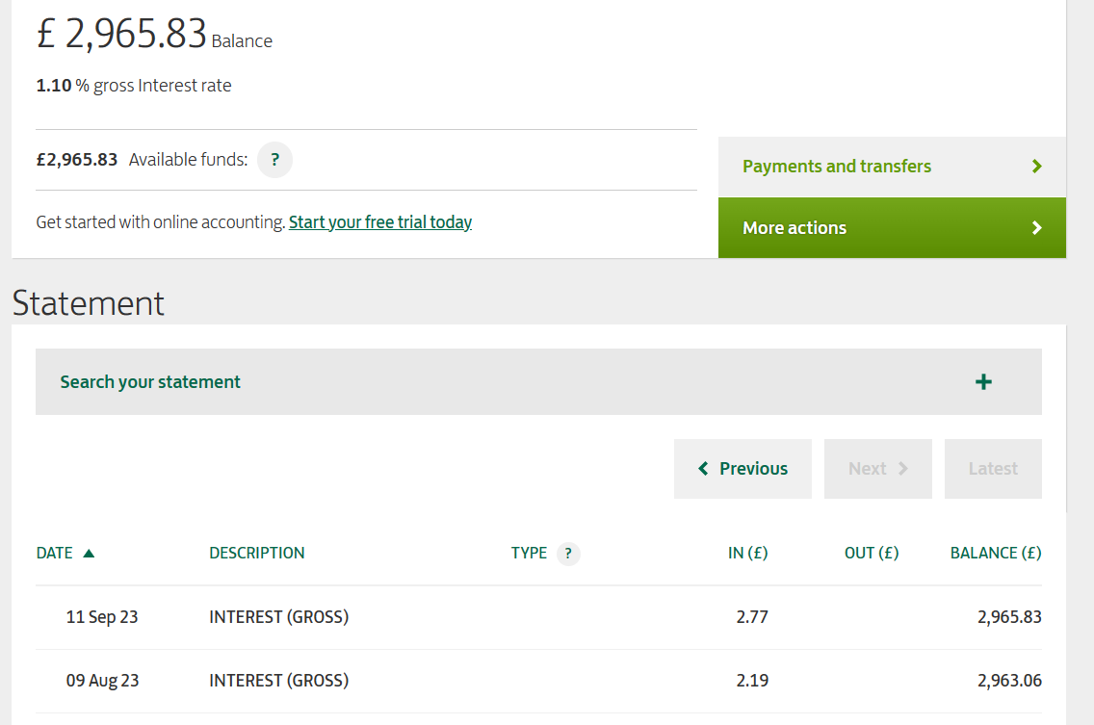

- To consider payment of the following:

L Bateman Salary July – Sep 2023 48 hours @ £14.48 £695.04
L Bateman Expenses (phone/allowance/stamps) £36.15
New Victory Hall Room Hire July £19.00
Countrystyle Recycling LTD Mixed glass recycling 6 x invoices £102.00
St Peters Church Grant towards grounds upkeep £250.00
Jack Hubbard Monkey Challenge wall £7410.00

All AGREED to be paid and the amount to cover the VAT for the climbing wall would be moved from the reserves until it could be replaced from the VAT reclaim next year.

Proposed Cllr Godfrey, seconded Cllr Craker, all in favour

Other matters
None

Date of Next Meeting
Thursday 19th October 2023 at 7.30pm New Victory Hall, Neatishead

The meeting closed at 8.35pm.

CHAIRMAN

